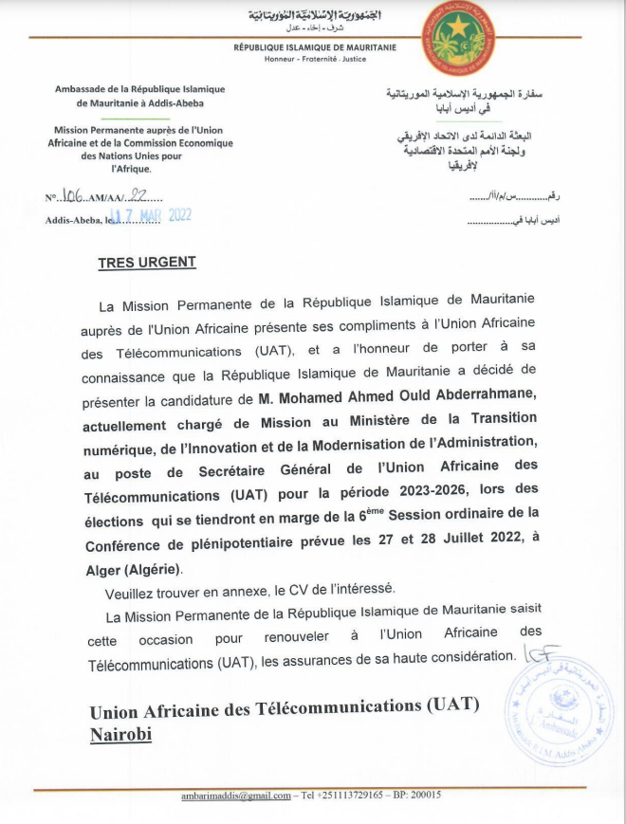

“Transforming Africa through digital technology with confidence”

Biographical data :
- Surname & First name: Mohamed Ahmed Ould ABDERRAHMANE
- Date and place of birth: 29/06/1968 in KIFFA - MAURITANIA
- Age: 52 years old
- Nationality: Mauritanian
- Family status: married and father of four children

Brief CV:

1) Academic training in the field of Telecommunications/ICT and public law:
- Diploma in Advanced Studies (DEA) in telecommunications at the he National Engineering School of Tunis (ENIT),
- Master of Public Law from Nouakchott University,
- Doctoral student in telecommunications at the Polytechnic Superior School (ESP) Univertsty of Cheikh Anta Diop, Dakar
2) training and improvement:
- Training on project management, good practices
- Training on leadership, team management, decision-making techniques and change management
- Finance training for senior executives
- Project Execution Risk Management Training
- Training on national and World Bank and EIB procurement procedures
- Training on the management of telecommunications in the new environment
- Training on reform, postal regulations and market studies

3) Scalable and diverse professional curriculum:
- Technical Advisor in charge of ICT and the postal sector,
- Advisor in charge of communication,
- Project and Program Coordinator,
- President and member of several commissions, committees and working groups,
- Policy Officer,
- Acting Secretary General.

4) Thorough knowledge of topics and challenges of the digital sector at the regional and international level in its capacity as a focal point for international and regional organizations and institutions active in this sector as well as through its participation in several conferences, colloquia, symposiums, forums, workshops and seminars, organized by renowned international and regional organizations and institutions such as ITU, ATU, GSMA, UPU, etc.

5) Member of several boards of directors and focal point of several institutions active in the digital sector at international and national level:
- Arabsat,
- Arab ICT Organization (AICTO),
- African Satellite Telecommunications Organization (RASCOM),
- International Telecommunications Satellite Organization (ITSO),
- Arab Maghreb Union (UMA),
- Multinational School of Telecommunications (ESMT-Dakar),
- Mauritel (1st operator in Mauritania),
- TDM (broadcaster in Mauritania),
- Mauripost (postal operator in Mauritania)

Candidate's view:
Slogan: " Transforming Africa through digital technology with confidence "
Candidacy Context:
The Government of the Islamic Republic of Mauritania, in accordance with the instructions of His Excellency the President of the Republic Mr. Mohamed Ould Cheikh El Ghazouani, is working for the development of Information and Communication Technologies as a lever for growth.
In “My Commitments for the Fatherland”, His Excellency the President of the Republic, proposed to the Mauritanian Nation a vision with new ambitions where knowledge, digital technology and innovation are called to play a driving role” - 29 July 2021.

Considering the importance of the digital sector in global policies and strategies, and considering the great hopes based on this sector to meet the challenges of the African continent and accelerate its socio-professional transformation the African Telecommunication Union is of vital importance in the coordination and leadership in this area.
In accordance with this strategic vision of our country, based on the awareness of the importance of this sector and the essential role played by the African Telecommunications Union (UAT) In its governance, the Government has decided to present the candidacy of Mr. Mohamed Ahmed Ould Abderrahmane as Secretary General of this organization.

he candidate has a strong involvement in the design and implementation of national sectoral strategies and policies in the field of digital technologies, both in their technical, political, legislative, regulatory and managerial dimensions. He has a pioneering experience marked by involvement in various sectoral strategies and initiatives at the international, African and Arab levels.
In addition, the candidate is a PhD student in telecommunications and a researcher in the legal field with an excellent knowledge of ICT policy and development. He is also supported by his professional skills, transversal knowledge and dynamic personality, open, committed, honest and rigorous.

Africa has a strong potential in the digital field, particularly because of its geostrategic position. Major advances are needed to generalize digital uses and develop an impactful digital industry.
Africa’s digital transformation is underway, bringing about change in all economic sectors and much-awaited social progress. The continent recorded the highest growth rates in the world for several indicators of growth in the telecommunications market.
According to the various international digital indexes and compared to other continents, Africa has significant potential for improvement.
The African continent’s transition to a digital economy, in particular in response to the challenges posed by the COVID-19 crisis and with a view to developing long-term economic resilience conducive to inclusion, requires a strong commitment from the African Telecommunications Union, which is the Continental Agency in charge of this sector.
Promoting Africa’s digital economy sector will improve the quality of basic services, strengthen transparency and accountability in the public sector and contribute to a human rights-friendly environment. Digital transformation can improve the delivery of public services, particularly in the areas of health, education, finance and agriculture, at a time when the COVID-19 pandemic is hitting hard across all sectors of the economy. The transition to a digital economy is changing the way people interact by improving the efficiency of development activities and providing new solutions in all sectors, with significant economic benefits while building resilience and generating meaningful economic growth.
African policies:
In 2019, the African Union presented the Digital Transformation Strategy for Africa (2020-2030), based on previous initiatives, after consultation with multiple stakeholders of the digital ecosystem in Africa. These stakeholders included the African Telecommunication Union. In line with Africa’s Agenda 2063 and the Sustainable Development Goals, this strategy aims to transform African economies and foster their integration by stimulating inclusive growth through digital technologies and innovation.
Macroeconomic context:
he economic and health crisis triggered by the COVID-19 pandemic has hit sub-Saharan Africa hard. The International Monetary Fund (IMF) updated its growth projections in June 2020, and now estimates that real GDP per capita is expected to contract by more than 4% and unemployment will continue to rise. Given the weakness of the region’s health systems and other underlying vulnerabilities, the health effects could increase. The digital economy sector is often more resilient.
n Africa, the 10-24 age group is the largest in the world, accounting for some 32% of the continent’s population (including more than 200 million aged 15-24). The continent’s productive capacity will explode in the coming years thanks to this supply of additional work, which benefits from an increasingly high level of education: UNESCO estimates that the proportion of24-year high school graduates are expected to increase from 42% to 59% over the next 20 years.
The transition to a digital economy:
The use of digital technologies is transforming economies and societies at unprecedented speed and scale, creating immense geopolitical, commercial, and socio-economic potential, but it also brings with it challenges that must be addressed.
According to the 2018 study by the International Telecommunication Union, a 10% increase in mobile broadband penetration in low-income economies leads to a 2% increase in GDP. In sub-Saharan Africa in particular, a 10% increase in mobile broadband penetration is expected to result in a 2.5% increase in GDP. The more securely and reliably people and objects are connected, the more data the continent creates that generates actionable analytics, considered the most valuable resource of the 21st century.
Best practices for security in a digital world:
Digital tools offer opportunities for dematerialisation for African economies and enable the deployment of new models. E-government strengthens democracies around the world by fostering greater accountability to citizens. To make the most of it, the value chain of the digital economy must be protected by the implementation of robust cyber defence policies and good cyber security practices.
Strengthening the digital economy increases the need to consider and invest in security. Maintaining trust in cyberspace is a prerequisite for harnessing the potential of the digital economy.
Commitment of the Candidate:
With its human, material and geostrategic potential, Africa can emerge thanks to digital technology. Driven by a firm will and strong attachment to our African continent, the candidate is committed to leading the necessary reforms and coordinating actions and making themselves available to all countries and stakeholders to safely achieve the digital transformation of the continent.
Mohamed Ahmed Ould Abderrahmane

